File > New>Library

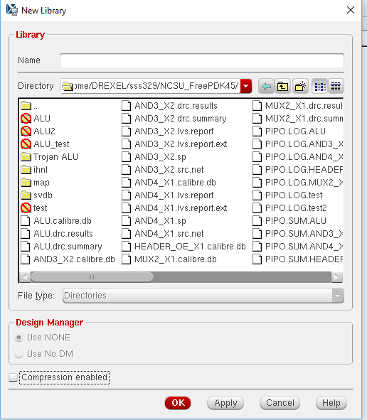

Name the Library and click ok

Attach to an existing technology library

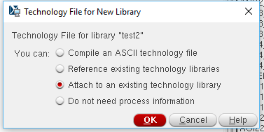

Attach to NangatOpenCellLibrary

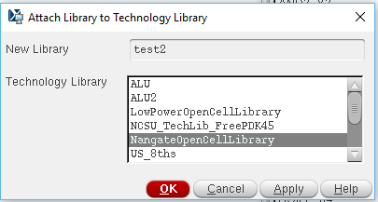

File>New>CellView

Create schematic

Create Layout

Change Grid Snap Spacing in Display settings before placing Slandered Cells

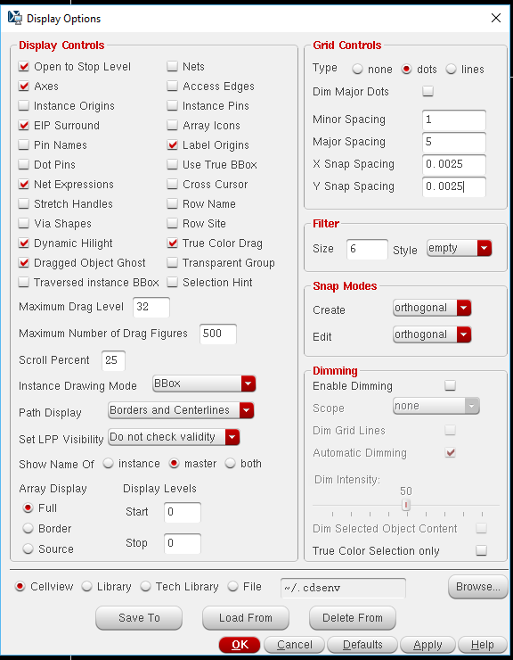

Add active layer, nimplant, and nwell to VDD!

Add active layer, pimplant, and pwell to GND!

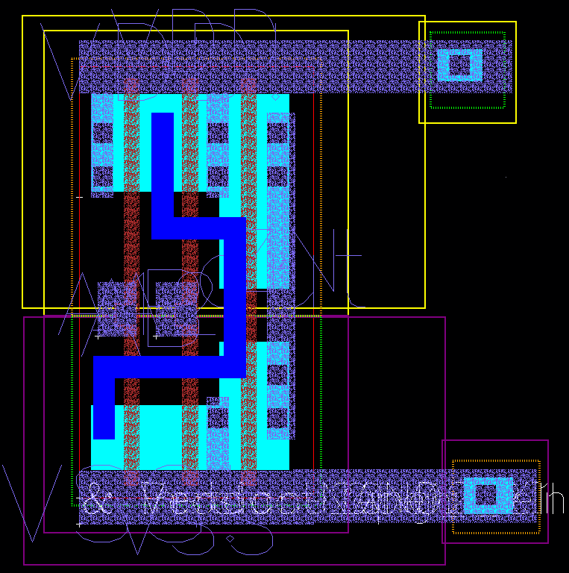

RunDRC check

Calibre > run mmDRC

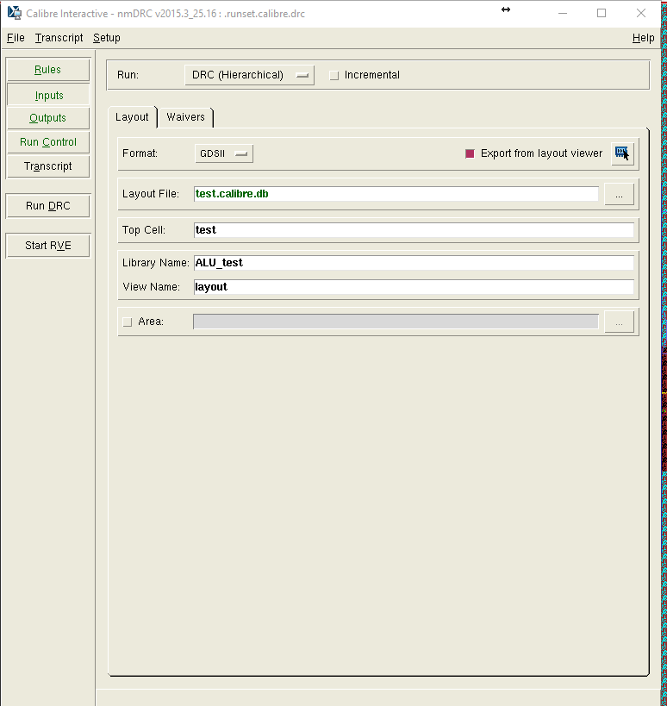

Run LVS check

Calibre> run nmLVS

Make sure export from layout viewer is checked

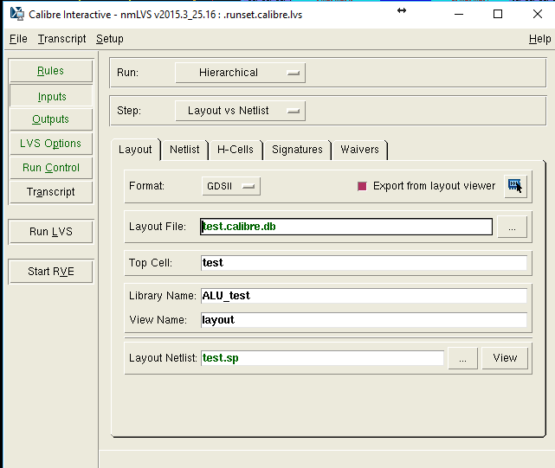

Go to setup > LVS Options>Database

Check Specify precision to 1000

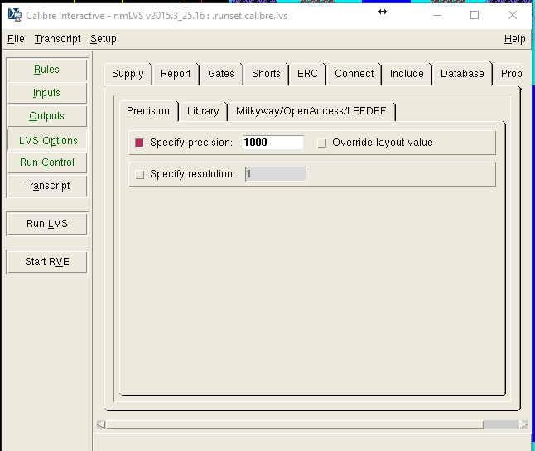

Go to setup > LVS Options > Include

Include these statements

LVS MAP DEVICE MP(PMOS_VTL) MP(PM)

LVS MAP DEVICE MN(NMOS_VTL) MN(NM)

